import pandas as pd
import matplotlib.pyplot as plt import numpy as np
import tensorflow as tf import re
from tensorflow.keras.preprocessing.text import Tokenizer import tensorflow as tf
from sklearn.metrics import accuracy_score
from sklearn.model_selection import train_test_split
from sklearn.metrics import accuracy_score, confusion_matrix, precision_score, recall_score
import seaborn as sns plt.style.use('ggplot')
Read the data
fake_df = pd.read_csv('/content/fake.csv') real_df = pd.read_csv('/content/true.csv')
Checking for null values
title text subject date
0
0
0
0
dtype: int64
title text subject
0
0
0
date 0
dtype: int64
fake_df.isnull().sum()

real_df.isnull().sum()
Checking for unique values for subject. We want both data frames to have a similar distribution.
fake_df.subject.unique()
array(['Technology', 'Health', 'Fake History', 'Science Fiction',
'Conspiracy', 'Alternative Medicine', 'Unexplained', 'Sci-Fi',
'Supernatural', 'Mystery'], dtype=object)
real_df.subject.unique()
array(['Security', 'Science', 'Economy', 'Computing', 'Astronomy',
'Politics', 'Energy', 'Education', 'Space', 'Technology'],
dtype=object)

Drop the date from the dataset, I don't think there is a strong correlation between date and validity of the news. As we see above, subjects are not distributed evenly. We do not want that to influence the accuracy of our classifier. Therefore, we need to drop that as well.
fake_df.drop(['date', 'subject'], axis=1, inplace=True) real_df.drop(['date', 'subject'], axis=1, inplace=True)
0 for fake news, and 1 for real news
fake_df['class'] = 0
real_df['class'] = 1
Check out the distribution of fake news compare to real news
plt.figure(figsize=(10, 5))
plt.bar('Fake News', len(fake_df), color='orange') plt.bar('Real News', len(real_df), color='green') plt.title('Distribution of Fake News and Real News', size=15) plt.xlabel('News Type', size=15)
plt.ylabel('# of News Articles', size=15)

total_len = len(fake_df) + len(real_df) plt.figure(figsize=(10, 5))
plt.bar('Fake News', len(fake_df) / total_len, color='orange') plt.bar('Real News', len(real_df) / total_len, color='green') plt.title('Distribution of Fake News and Real News', size=15) plt.xlabel('News Type', size=15)
plt.ylabel('Proportion of News Articles', size=15)
Text(0, 0.5, 'Proportion of News Articles')

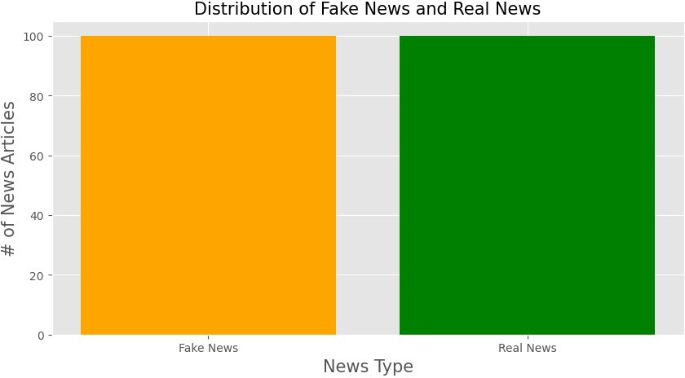
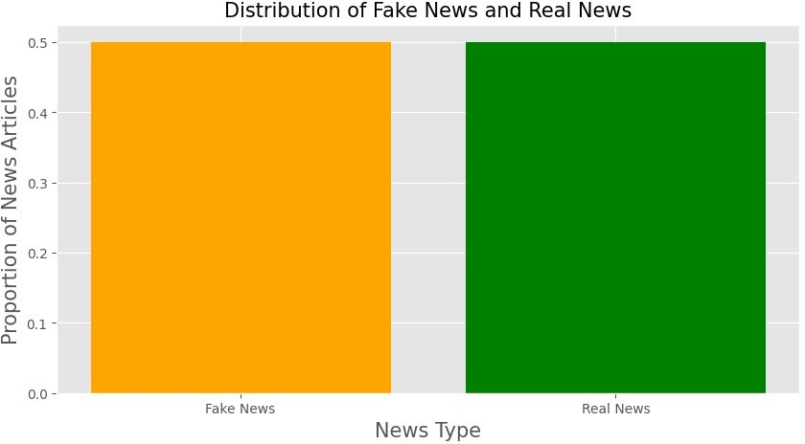
print('Difference in news articles:',len(fake_df)-len(real_df))
Difference in news articles: 0
news_df = pd.concat([fake_df, real_df], ignore_index=True, sort=False) news_df

Combining the title with the text, it is much easier to process this way.
news_df['text'] = news_df['title'] + news_df['text'] news_df.drop('title', axis=1, inplace=True)
Split into training and testing
features = news_df['text'] targets = news_df['class']
X_train, X_test, y_train, y_test = train_test_split(features, targets, test_size=0.20, random_state=18)
Normalizing our data: lower case, get rid of extra spaces, and url links.
def normalize(data): normalized = [] for i in data:
i = i.lower()
# get rid of urls
i = re.sub('https?://\S+|www\.\S+', '', i)
# get rid of non words and extra spaces
i = re.sub('\\W', ' ', i)
i = re.sub('\n', '', i)
i = re.sub(' +', ' ', i)

i = re.sub('^ ', '', i)
i = re.sub(' $', '', i) normalized.append(i)
return normalized
X_train = normalize(X_train) X_test = normalize(X_test)
max_vocab = 10000
tokenizer = Tokenizer(num_words=max_vocab) tokenizer.fit_on_texts(X_train)
Convert text to vectors, our classifier only takes numerical data.
# tokenize the text into vectors
X_train = tokenizer.texts_to_sequences(X_train) X_test = tokenizer.texts_to_sequences(X_test)
Apply padding so we have the same length for each article
X_train = tf.keras.preprocessing.sequence.pad_sequences(X_train, padding='post', maxlen=256)
X_test = tf.keras.preprocessing.sequence.pad_sequences(X_test, padding='post', maxlen=256)
Building the RNN.
model = tf.keras.Sequential([ tf.keras.layers.Embedding(max_vocab, 128), tf.keras.layers.Bidirectional(tf.keras.layers.LSTM(64,
return_sequences=True)), tf.keras.layers.Bidirectional(tf.keras.layers.LSTM(16)), tf.keras.layers.Dense(64, activation='relu'), tf.keras.layers.Dropout(0.5),
tf.keras.layers.Dense(1)
])
model.summary() Model: "sequential"
┏━━━━━━━━━━━━━━━━━━━━━━━━━━━━━━━━━━━━━━┳━━━━━━━━━━━━━━━━━━━━━━━━━━━━━┳
━━━━━━━━━━━━━━━━━┓
Param # ┃
┡━━━━━━━━━━━━━━━━━━━━━━━━━━━━━━━━━━━━━━╇━━━━━━━━━━━━━━━━━━━━━━━━━━━━━╇
━━━━━━━━━━━━━━━━━┩
0 (unbuilt) │
│ embedding (Embedding) │ ? │
┃ Layer (type) ┃ Output Shape ┃

├──────────────────────────────────────┼─────────────────────────────┼
─────────────────┤
│ bidirectional (Bidirectional) │ ? │
0 (unbuilt) │
├──────────────────────────────────────┼─────────────────────────────┼
─────────────────┤
│ bidirectional_1 (Bidirectional) │ ? │
0 (unbuilt) │
├──────────────────────────────────────┼─────────────────────────────┼
─────────────────┤
│ dense (Dense) │ ? │
0 (unbuilt) │
├──────────────────────────────────────┼─────────────────────────────┼
─────────────────┤
│ dropout (Dropout) │ ? │
0 │
├──────────────────────────────────────┼─────────────────────────────┼
─────────────────┤
│ dense_1 (Dense) │ ? │
0 (unbuilt) │
└──────────────────────────────────────┴─────────────────────────────┴
─────────────────┘
Total params: 0 (0.00 B)
Trainable params: 0 (0.00 B)
Non-trainable params: 0 (0.00 B)
We are going to use early stop, which stops when the validation loss no longer improve.
early_stop = tf.keras.callbacks.EarlyStopping(monitor='val_loss', patience=2, restore_best_weights=True) model.compile(loss=tf.keras.losses.BinaryCrossentropy(from_logits=True
),
optimizer=tf.keras.optimizers.Adam(1e-4), metrics=['accuracy'])
history = model.fit(X_train, y_train, epochs=10,validation_split=0.1, batch_size=30, shuffle=True, callbacks=[early_stop])
Epoch 1/10
5/5 ━━━━━━━━━━━━━━━━━━━━ 13s 954ms/step - accuracy: 0.4894 - loss: 0.6931 - val_accuracy: 0.4375 - val_loss: 0.6909
Epoch 2/10
5/5 ━━━━━━━━━━━━━━━━━━━━ 2s 456ms/step - accuracy: 0.5032 - loss: 0.6930 - val_accuracy: 0.4375 - val_loss: 0.6884
Epoch 3/10
5/5 ━━━━━━━━━━━━━━━━━━━━ 2s 453ms/step - accuracy: 0.4676 - loss: 0.6892 - val_accuracy: 0.4375 - val_loss: 0.6853

Epoch 4/10
5/5 ━━━━━━━━━━━━━━━━━━━━ 2s 448ms/step - accuracy: 0.4690 - loss: 0.6857 - val_accuracy: 0.4375 - val_loss: 0.6819
Epoch 5/10
5/5 ━━━━━━━━━━━━━━━━━━━━ 3s 448ms/step - accuracy: 0.4676 - loss: 0.6816 - val_accuracy: 0.4375 - val_loss: 0.6777
Epoch 6/10
5/5 ━━━━━━━━━━━━━━━━━━━━ 4s 795ms/step - accuracy: 0.4880 - loss: 0.6759 - val_accuracy: 0.4375 - val_loss: 0.6727
Epoch 7/10
5/5 ━━━━━━━━━━━━━━━━━━━━ 3s 447ms/step - accuracy: 0.4972 - loss: 0.6741 - val_accuracy: 0.4375 - val_loss: 0.6661
Epoch 8/10
5/5 ━━━━━━━━━━━━━━━━━━━━ 3s 444ms/step - accuracy: 0.5162 - loss: 0.6662 - val_accuracy: 0.4375 - val_loss: 0.6574
Epoch 9/10
5/5 ━━━━━━━━━━━━━━━━━━━━ 3s 435ms/step - accuracy: 0.4565 - loss: 0.6580 - val_accuracy: 0.4375 - val_loss: 0.6468
Epoch 10/10
5/5 ━━━━━━━━━━━━━━━━━━━━ 3s 563ms/step - accuracy: 0.4824 - loss: 0.6430 - val_accuracy: 0.4375 - val_loss: 0.6332
Visualize our training over time
history_dict = history.history
acc = history_dict['accuracy']
val_acc = history_dict['val_accuracy'] loss = history_dict['loss']
val_loss = history_dict['val_loss'] epochs = history.epoch
plt.figure(figsize=(12,9))
plt.plot(epochs, loss, 'r', label='Training loss') plt.plot(epochs, val_loss, 'b', label='Validation loss') plt.title('Training and validation loss', size=20) plt.xlabel('Epochs', size=20)
plt.ylabel('Loss', size=20) plt.legend(prop={'size': 20}) plt.show()
plt.figure(figsize=(12,9))
plt.plot(epochs, acc, 'g', label='Training acc') plt.plot(epochs, val_acc, 'b', label='Validation acc') plt.title('Training and validation accuracy', size=20) plt.xlabel('Epochs', size=20)
plt.ylabel('Accuracy', size=20) plt.legend(prop={'size': 20})

plt.ylim((0.5,1)) plt.show()
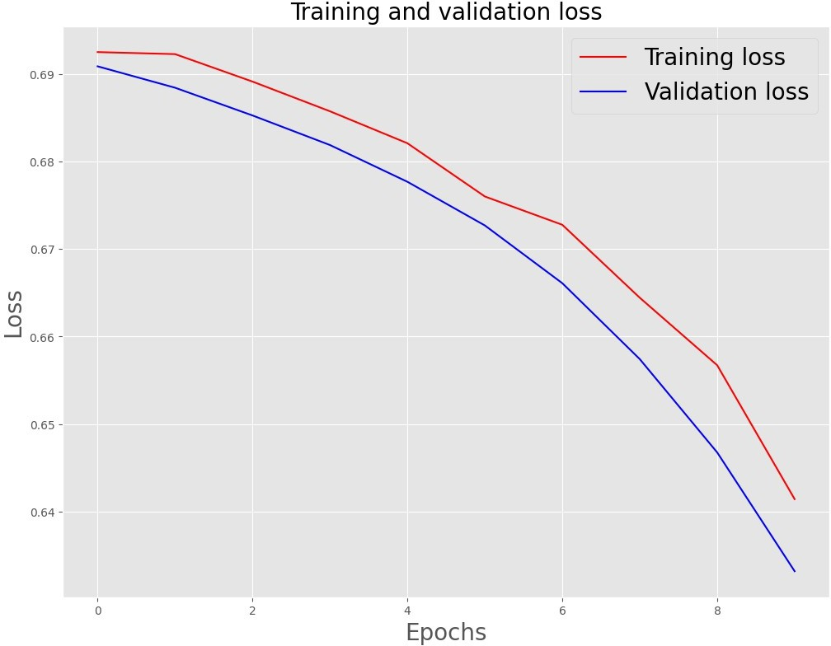

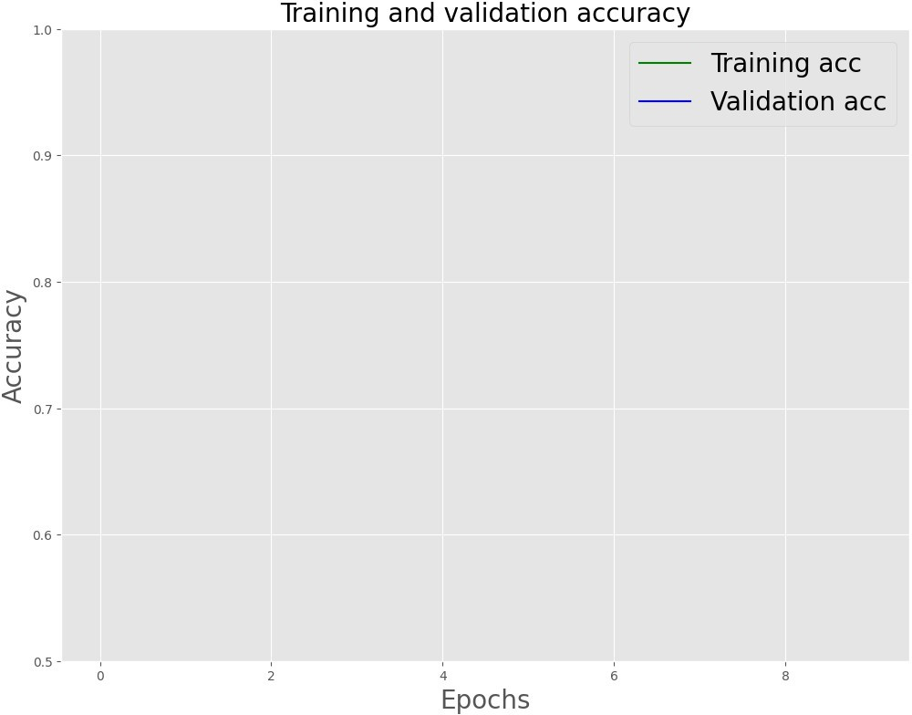
Evaluate the testing set
model.evaluate(X_test, y_test)
2/2 ━━━━━━━━━━━━━━━━━━━━ 0s 79ms/step - accuracy: 0.5917 - loss: 0.6403
[0.639633297920227, 0.574999988079071]
pred = model.predict(X_test) binary_predictions = []
for i in pred: if i >= 0.5:
binary_predictions.append(1) else:
binary_predictions.append(0)
2/2 ━━━━━━━━━━━━━━━━━━━━ 1s 714ms/step

print('Accuracy on testing set:', accuracy_score(binary_predictions, y_test))
print('Precision on testing set:', precision_score(binary_predictions, y_test))
print('Recall on testing set:', recall_score(binary_predictions, y_test))
Accuracy on testing set: 0.575 Precision on testing set: 0.0 Recall on testing set: 0.0
/usr/local/lib/python3.11/dist-packages/sklearn/metrics/
_classification.py:1565: UndefinedMetricWarning: Recall is ill-defined and being set to 0.0 due to no true samples. Use `zero_division` parameter to control this behavior.
_warn_prf(average, modifier, f"{metric.capitalize()} is", len(result))
Confusion matrix
matrix = confusion_matrix(binary_predictions, y_test, normalize='all') plt.figure(figsize=(16, 10))
ax= plt.subplot()
sns.heatmap(matrix, annot=True, ax = ax)
# labels, title and ticks ax.set_xlabel('Predicted Labels', size=20) ax.set_ylabel('True Labels', size=20) ax.set_title('Confusion Matrix', size=20) ax.xaxis.set_ticklabels([0,1], size=15) ax.yaxis.set_ticklabels([0,1], size=15)
[Text(0, 0.5, '0'), Text(0, 1.5, '1')]

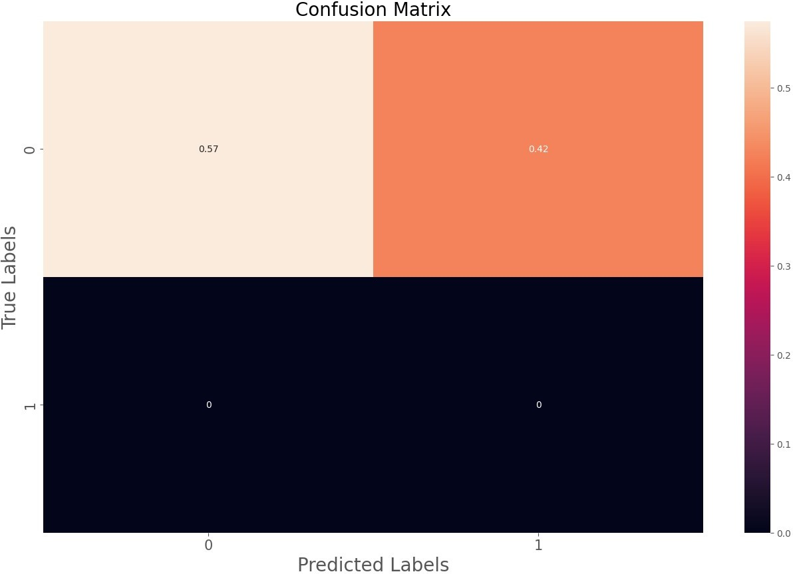
Saves the weights for visualiation
e = model.layers[0]
weights = e.get_weights()[0]
print(weights.shape) # shape: (vocab_size, embedding_dim)
(10000, 128)
word_index = list(tokenizer.word_index.keys()) word_index = word_index[:max_vocab-1]
Write to file so we can use tensorflow's embedding projector to visualize what our network learned. This is only based on the fake news dataset.
import io
out_v = io.open('fakenews_vecs.tsv', 'w', encoding='utf-8') out_m = io.open('fakenews_meta.tsv', 'w', encoding='utf-8')
for num, word in enumerate(word_index):
vec = weights[num+1] # skip 0, it's padding.
out_m.write(word + "\n")

out_v.write('\t'.join([str(x) for x in vec]) + "\n") out_v.close()
out_m.close()
Embedding Projector: http://projector.tensorflow.org/ Picture credits: https://www.tensorflow.org/tensorboard/images/embedding_projector.png?raw=1
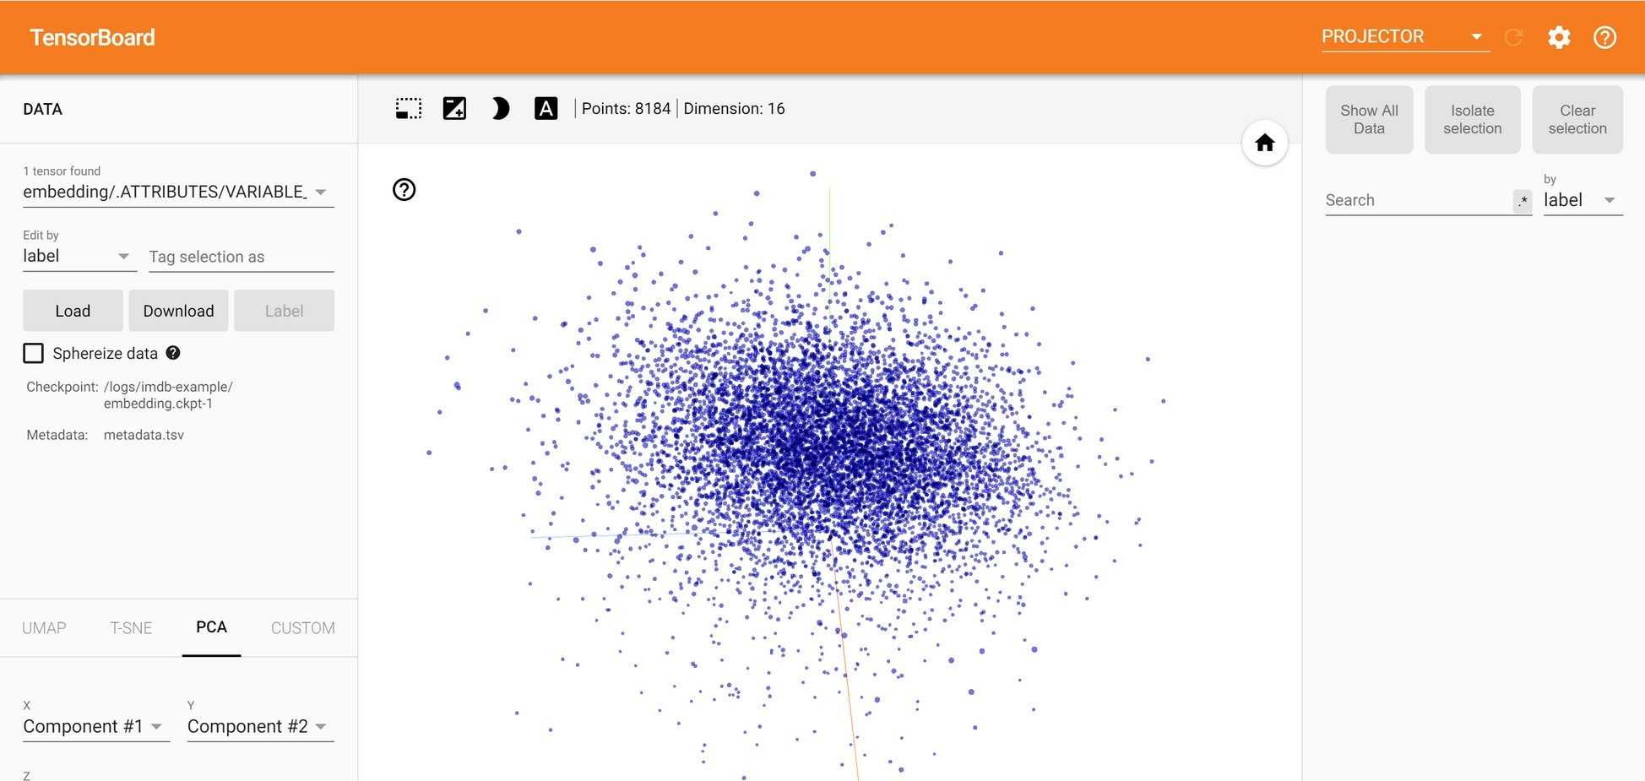
fake_df['flag'] = 0
real_df['flag'] = 1
df = pd.DataFrame()
df = pd.concat([real_df, fake_df], ignore_index=True) nlp = df
df.info()
<class 'pandas.core.frame.DataFrame'> Int64Index: 44898 entries, 0 to 23480 Data columns (total 4 columns):
# Column Non-Null Count Dtype

- class 44898 non-null int64
- flag 44898 non-null int64 dtypes: int64(2), object(2) memory usage: 1.7+ MB
from sklearn.feature_extraction.text import TfidfVectorizer
corpus = nlp[nlp['flag'] == 1]['title'].iloc[0:500] # We will take a slice of fake news, to see what vocabulary there looks like
- title 44898 non-null object
- text 44898 non-null object

tfidf1 = TfidfVectorizer()
vecs = tfidf1.fit_transform(corpus)
# Use get_feature_names_out() instead of get_feature_names()
feature_names = tfidf1.get_feature_names_out() dense = vecs.todense()
list_words = dense.tolist()
df_words = pd.DataFrame(list_words, columns=feature_names)
from wordcloud import WordCloud, STOPWORDS, ImageColorGenerator df_words.T.sum(axis=1)
Cloud = WordCloud(background_color="white", max_words=100).generate_from_frequencies(df_words.T.sum(axis=1))
import matplotlib.pyplot as plt plt.figure(figsize=(12,5)) plt.imshow(Cloud, interpolation='blackman')
<matplotlib.image.AxesImage at 0x7ac44be42f90>

import nltk
# Download the 'punkt_tab' data package
nltk.download('punkt_tab')
from nltk import word_tokenize
nlp['title'] = nlp['title'].apply(lambda x: word_tokenize(str(x)))

[nltk_data] Downloading package punkt_tab to /root/nltk_data... [nltk_data] Unzipping tokenizers/punkt_tab.zip.
from nltk.stem import SnowballStemmer
snowball = SnowballStemmer(language='english')
nlp['title'] = nlp['title'].apply(lambda x: [snowball.stem(y) for y in x])
nlp['title'] = nlp['title'].apply(lambda x: ' '.join(x)) from nltk.corpus import stopwords
nltk.download('words') nltk.download('stopwords')
stopwords = stopwords.words('english')
[nltk_data] Downloading package words to /root/nltk_data... [nltk_data] Unzipping corpora/words.zip.
[nltk_data] Downloading package stopwords to /root/nltk_data... [nltk_data] Unzipping corpora/stopwords.zip.
from sklearn.feature_extraction.text import TfidfVectorizer
tfidf = TfidfVectorizer()
X_text = tfidf.fit_transform(nlp['title'])
from sklearn.model_selection import train_test_split X_train, X_test, y_train, y_test = train_test_split(X_text, nlp['flag'], test_size=0.33, random_state=1)
scores = {}
from sklearn.svm import LinearSVC
from sklearn.model_selection import cross_val_score from sklearn.metrics import accuracy_score
clf = LinearSVC(max_iter=100, C=1.0) clf.fit(X_train, y_train)
y_pred_SVM = clf.predict(X_test)
print(cross_val_score(clf, X_text, nlp['flag'], cv=3)) print(accuracy_score(y_pred_SVM, y_test))
scores['LinearSVC'] = accuracy_score(y_pred_SVM, y_test)
[1. 1. 1.]
1.0
from sklearn.metrics import classification_report, confusion_matrix from sklearn.metrics import ConfusionMatrixDisplay

import matplotlib.pyplot as plt
# ... (rest of your code) ...
# Instead of:
# plot_confusion_matrix(clf , X_test, y_test)
# Use this:
disp = ConfusionMatrixDisplay.from_estimator(clf, X_test, y_test) disp.plot()
plt.grid(False)
# ... (rest of your code) ...
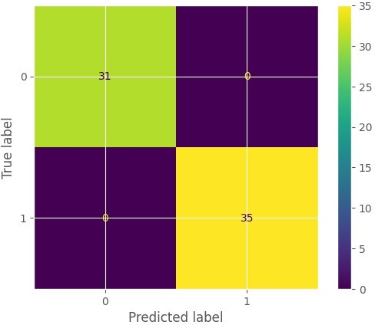

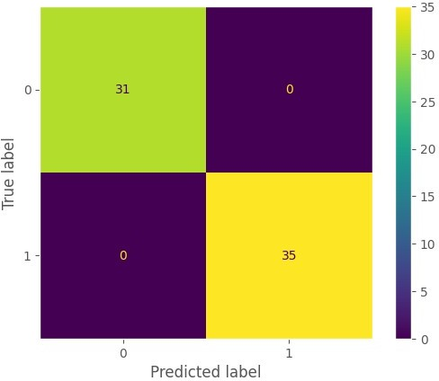
from sklearn.naive_bayes import MultinomialNB
clf2 = MultinomialNB() clf2.fit(X_train, y_train)
y_pred_MNB = clf2.predict(X_test) print(cross_val_score(clf2, X_text, nlp['flag'], cv=3)) print(accuracy_score(y_pred_MNB, y_test))
scores['MultinomialNB'] = accuracy_score(y_pred_MNB, y_test)
[1. 1. 1.]
1.0
print(confusion_matrix(y_test,y_pred_MNB)) print('\n') print(classification_report(y_test,y_pred_MNB))
[[31 0]
[ 0 35]]

precision recall f1-score support
0 1.00 1.00 1.00 31

 | 1 | 1.00 | 1.00 | 1.00 | 35
 | accuracy |  |  | 1.00 | 66
 | macro avg | 1.00 | 1.00 | 1.00 | 66
 | weighted avg | 1.00 | 1.00 | 1.00 | 66

from sklearn.metrics import classification_report, confusion_matrix from sklearn.metrics import ConfusionMatrixDisplay
import matplotlib.pyplot as plt
# Instead of:
# plot_confusion_matrix(clf2 , X_test, y_test)
# Use this:
disp = ConfusionMatrixDisplay.from_estimator(clf2, X_test, y_test)
# Or if you have predictions already:
# disp = ConfusionMatrixDisplay.from_predictions(y_test, y_pred_MNB)
disp.plot() plt.grid(False)




print(confusion_matrix(y_test,y_pred_XGB)) print('\n') print(classification_report(y_test,y_pred_MNB))
[[31 0]
[ 0 35]]
precision recall f1-score support

0 | 1.00 | 1.00 | 1.00 | 31
1 | 1.00 | 1.00 | 1.00 | 35
accuracy |  |  | 1.00 | 66
macro avg | 1.00 | 1.00 | 1.00 | 66
weighted avg | 1.00 | 1.00 | 1.00 | 66

